UAT Plan

for

RepTracker sprint 1.0

Index

1. Scope 3

1.1. Objectives and business requirements 3

1.2. Scope 3

2. Testing team 4

3. Environmental requirements 5

3.1. Hardware requirements 5

3.2. Software requirements 5

4. Test Scripts 1

# Scope

## Objectives and business requirements

In this section, outline the business requirements. In other words:

We will be testing the timer and its setting option as well as the landing page for the user documentation.

## Scope

* Testing the UI of the landing page of the user documentation
* Testing the timer to check if the duration is correct
* Testing the timer setting buttons
* Test the notification system of the timer

## System Diagrams

Storyboard:

Story board is missing the user documentation page

Structure chart:

(first half)

(second half) This storyboard is missing the user documentation page

Dataflow:

Data flow is missing user documentation page

Context diagram:

Flowchart:

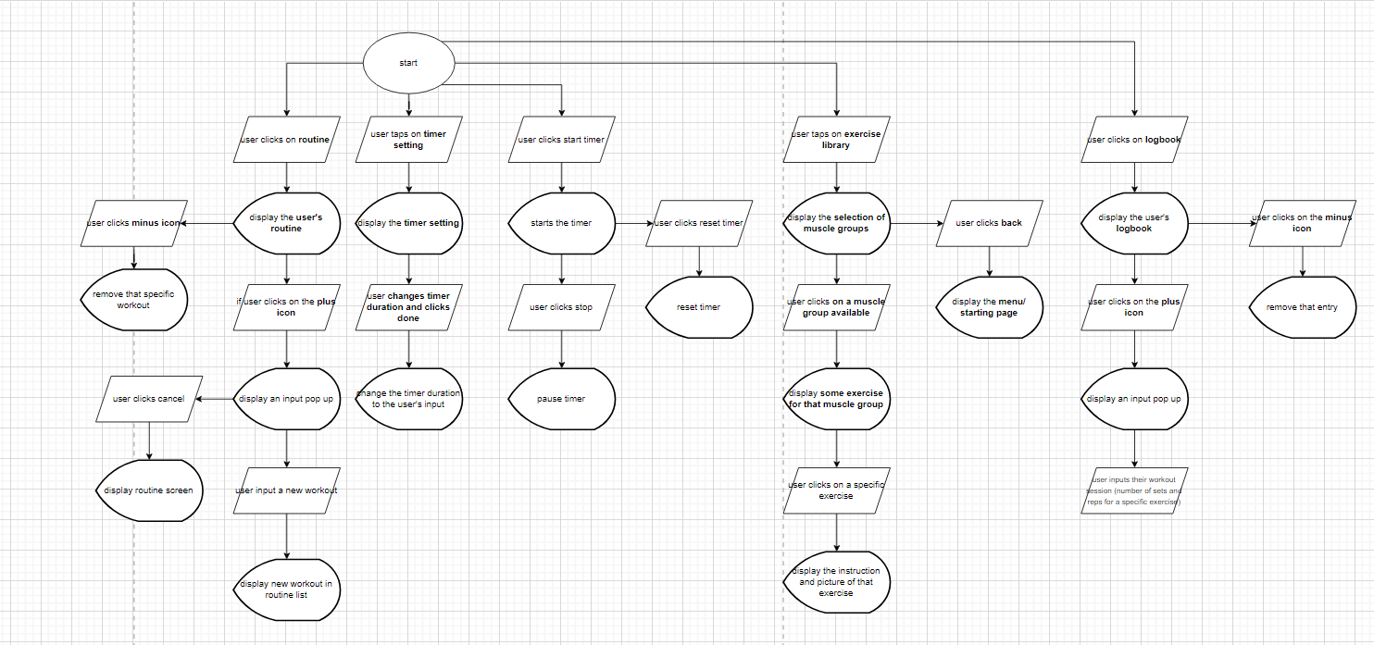

Flowchart is missing user documentation page

# Testing team

In this section, list out members of your QA team and what their roles will be during UAT.

|  |  |
| --- | --- |
| **Name** | **Responsibilities** |
| Chris Putra | Testing the UI of the user documentation |
| Chris Putra | Testing the timer |
|  |  |
|  |  |
|  |  |

# Environmental requirements

## Hardware requirements

Window PC

## Software requirements

If any extra software or dependencies must be downloaded and installed, list them here.

Google chrome (PC)

Google (android)

Safari (phone)

## Network requirements

Have access to internet

# Test Scripts

This section is more important than it seems—it is crucial that both the QA team and the testers know what features must be tested, especially if you’re testing a lot at once.

|  |  |  |  |  |
| --- | --- | --- | --- | --- |
| **Test** | **Describe the feature being tested** | **Describe the user input or test data** | **Describe the pass criteria** |  |
| 1 | Page displays the correct UI | User needs to first navigate to <https://tempehs.github.io/2024SDD-Linh-RepTracker/> which is accessible through GitHub (on pc) | Page loads a display similar to the one above | Tester name: Chris Putra   |  |  | | --- | --- | | X | PASS | |  | FAIL |   Observations:  The page loads |
| 2 | Timer starts and resets correctly | User needs to click start on the timer and reset the timer when it ends or when it is running | The timer should start counting down and displays the word reset in the middle of the circle button. The timer should reset back to the original time once clicked reset | Tester name: Chris Putra   |  |  | | --- | --- | | X | PASS | |  | FAIL |   Observations:  The timer starts and resets properly |
| 3 | Test the timer setting buttons | User needs to click on ‘m’ and ‘s’ buttons and make observation on whether the timer updates accordingly. | The timer duration should increase or decrease in seconds when clicked on the ‘s’ button. The timer duration should increase or decrease in minutes when clicked on the ‘m’ button. | Tester name: Chris Putra   |  |  | | --- | --- | | X | PASS | |  | FAIL |   Observations:  Timer increases and decreases accordingly |
| 4 | Test the duration of the timer | Before performing this test, start and reset the timer as it is not properly loaded in when first opened. Once that has been completed, start a stopwatch when the timer starts and check that the duration of the timer is correct | The duration should be the same | Tester name: Peter Vo   |  |  | | --- | --- | | X | PASS | |  | FAIL |   Observations:  Duration is correct |
| 5 | Landing page for user documentation loads | User needs to click on the documentation button | Page should look like this | Tester name: Peter Vo   |  |  | | --- | --- | | X | PASS | |  | FAIL |   Observations:  Page loads properly |
| 6 | Test on mobile devices | Repeat the process for mobile devices but the notification will not work | Results should be the same | Tester name: Peter Vo   |  |  | | --- | --- | | X | PASS | |  | FAIL |   Observations:  Everything works and loads as it should |